**1.0 Executive Summary**

OA$IS and Co’s data operations stand at a critical inflection point. While our current systems serve current operational needs, they do not support the safe and efficient introduction of generative and agentic AI into the landscape. This strategic framework outlines our vision to implement an AI-powered compensation governance framework that will fundamentally transform how we approach hourly workforce compensation decisions, reduce operational overhead by 50%, and position Amazon as a leader in data-driven compensation management.

The democratization of tech, through AI, has moved faster than our systems were ready for. Today, when Business Intelligence Engineers (BIEs), Data Engineers (DEs), and non-technical users leverage these new capabilities, the biggest obstacle they face is data access to data we own. Today, these users can now build solutions for real business problems – but struggle to deploy these solutions due to technical limitations. To overcome these barriers, we have set a 2026 goal to “Develop and implement a comprehensive framework that enables compensation teams to securely leverage Generative AI by implementing authenticated data access, privacy-protecting pipelines, document integration capabilities, and automated monitoring systems achieving 95% accuracy across compensation tools, while establishing robust governance protocols including documentation standards, audit mechanisms, and ethical guidelines.”

### 2.0 Current Architecture Limitations

Amazon's hourly workforce compensation analytics infrastructure operates through fragmented systems that prevent us from realizing the full potential of generative AI capabilities. Key limitations include:

**Data Silos and Access Barriers**: Compensation data exists in isolated repositories across Redshift, WorkDocs, wikis, and workforce management systems, with no unified mechanism for AI systems to access and correlate this information safely. SAML-federated Redshift access creates integration barriers that prevent seamless knowledge flow.

**Ownership and Maintenance Gaps**: BIEs and DEs build point solutions that often become "orphaned" when team members transition to new roles. Without clear ownership models, critical AI systems lack proper maintenance and updates, leading to degraded performance over time.

**Inconsistent Validation Protocols**: Different teams implement varying accuracy standards and validation protocols for AI-powered tools, creating compliance gaps and reducing confidence in hourly compensation decisions, particularly for minimum wage compliance and shift differential optimization.

**Limited Analytical Capabilities**: Operations managers and compensation analysts rely on static reports rather than dynamic, contextual analysis that generative AI enables. When market conditions shift rapidly or new regulations emerge, our systems force us to react slowly rather than proactively adjust hourly compensation strategies.

These limitations not only impact operational efficiency but also create significant business risks through potential regulatory non-compliance, market misalignment, and delayed decision-making for our hourly workforce compensation strategies.

### 3.0 Strategic Framework Components

Our framework addresses these challenges through four core pillars:

**1. Knowledge Integration and Access**

The foundation of our framework leverages Amazon Kendra to create a unified knowledge base that automatically ingests and processes content from WorkDocs, internal wikis, hourly workforce policies, state and local wage regulations, and labor market data. This integration enables AI agents to access current, accurate information on hourly wage requirements and local labor conditions while maintaining strict governance controls.

**2. Governance and Ownership Structure**

We will implement a dual ownership model where each AI system has both a designated business owner from the hourly compensation team and a technical owner responsible for maintenance and updates. This structure eliminates the "orphaned AI" problem while ensuring domain expertise guides all system development and enhancements. The model includes:

* Comprehensive system registry tracking all AI tools
* Clear ownership transition protocols
* Bi-weekly governance audits to maintain quality
* Automated monitoring against 95% confidence threshold

**3. Secure Access and Democratization**

The framework balances democratized access with robust security through:

* Role-based access controls for different user personas
* Natural language interfaces that empower operations managers
* Comprehensive audit trails of all AI interactions
* Model Context Protocol (MCP) integration for secure knowledge access
* Attribute-based access control systems for dynamic permission management

**4. Operational Excellence and Automation**

To achieve our goal of 50% reduction in manual tasks, the framework implements:

* Automated compliance monitoring for state and local wage laws
* Real-time market intelligence for hourly wage competitiveness
* Shift differential optimization through pattern analysis
* Seasonal workforce planning through predictive analytics
* Automated documentation and audit processes

### 4.0 Implementation Approach

Our implementation follows a phased approach that balances rapid progress with careful validation:

**Phase 1: Foundation (Months 1-3)**

* Establish governance council and operational teams
* Implement Amazon Kendra integration for knowledge base
* Deploy initial AI agents for wage compliance verification
* Create documentation templates and standards
* Begin pilot programs with select operations teams

**Phase 2: Core Capabilities (Months 4-9)**

* Roll out enhanced QuickSight dashboards with AI insights
* Implement automated compliance monitoring using RAG models
* Deploy natural language interfaces for operations managers
* Establish comprehensive bias detection protocols
* Launch governance monitoring dashboard

**Phase 3: Advanced Intelligence (Months 10-12)**

* Implement predictive analytics for hourly workforce planning
* Deploy agent chains for complex analyses
* Complete integration with existing operational tools
* Achieve and maintain 95% confidence threshold
* Reach 50% reduction in manual tasks

### 5.0 Business Impact

This framework will deliver substantial business value across multiple dimensions:

**Operational Efficiency**: 50% reduction in manual tasks will free compensation analysts and operations managers to focus on strategic initiatives rather than routine data gathering and compliance checking.

**Decision Quality**: Recommendations meeting the 95% confidence threshold will significantly improve hourly wage decision accuracy, particularly for complex scenarios involving multiple state regulations or rapidly changing market conditions.

**Compliance Assurance**: Automated monitoring of state and local wage laws will reduce risk of non-compliance, particularly for hourly workers across different jurisdictions with varying minimum wage and overtime requirements.

**Strategic Advantage**: Real-time market intelligence will enable faster response to competitive pressures, helping Amazon maintain its position as an employer of choice for hourly workers across all markets.

### 6.0 Summary

The question is not whether AI will transform hourly workforce compensation management, it's whether we will lead that transformation or be forced to catch up later. By implementing this framework now, we position Amazon at the forefront of compensation innovation, delivering better outcomes for our hourly employees while operating more efficiently and effectively.

This initiative represents more than a technology upgrade; it's a fundamental reimagining of how hourly compensation decisions are made, analyzed, and implemented. The organizations that embrace this transformation will have significant competitive advantages in attracting, retaining, and managing hourly talent in an increasingly complex business environment.

## Appendices

### Appendix A: Visual Architecture Overview

#### A1: Three-Layer Architecture - Core Components

This simplified diagram shows how the AI Governance Framework is structured in three clear layers:

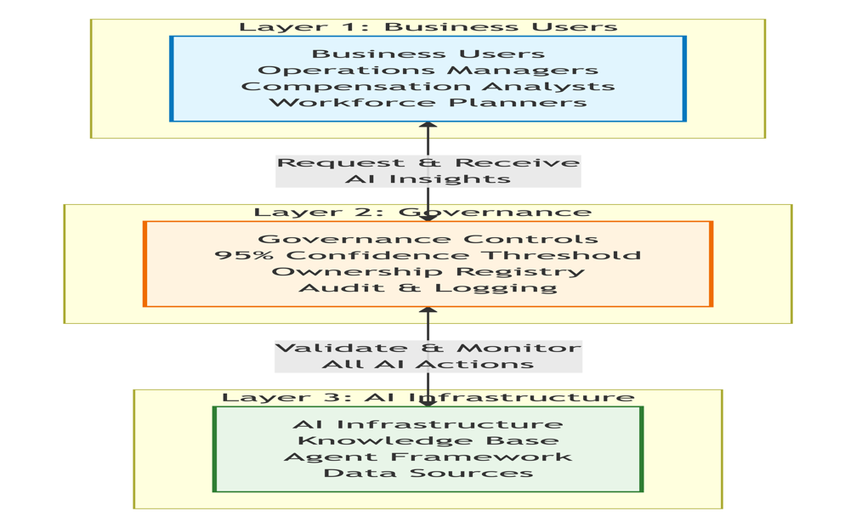

#### A2: How Hourly Workforce Users Access AI Capabilities

This diagram illustrates how different hourly workforce stakeholders interact with AI capabilities through familiar tools:

#### 

#### A3: Knowledge Integration for Hourly Workforce Insights

This diagram shows how the knowledge base integrates information from multiple sources to provide accurate hourly compensation insights:

### 

### Appendix B: Hourly Compensation AI Training Data Examples

**What "Training on Hourly Compensation Data" Actually Means:**

**Example 1: Local Market Wage Intelligence**

Training Input: "FC Associate 1 in Chicago typically earns $18.50-$22.00 per hour according to labor market surveys from Q2 2024. Internal Amazon data shows our FC Associates in Chicago average $19.75 per hour. Local market movement shows 5% increase year-over-year due to competition from other warehousing operations."

AI Learning: The model learns to correlate job levels, locations, labor market data sources, and trend analysis to provide contextually relevant recommendations for hourly workers.

Resulting AI Capability: When asked "What should we pay new FC Associates in Chicago?", the AI responds with market-informed recommendations that consider both external competitiveness and internal equity across facilities in the region.

**Example 2: Shift Differential Pattern Recognition**

Training Input: Historical analysis showing that night shift differentials in Phoenix facilities increased from $1.50 to $2.00 in Q1 2023 due to retention challenges, resulting in 15% lower attrition compared to facilities that maintained the $1.50 differential.

AI Learning: The model identifies patterns showing effectiveness of different shift differential strategies across regions and facility types.

Resulting AI Capability: The AI can recommend shift differential adjustments based on local conditions, stating "Current night shift differential of $1.50 in Detroit facilities shows 23% higher attrition than similar facilities. Consider evaluating an increase to $2.00 based on successful outcomes in comparable markets.”

**Example 3: Compliance Policy Application Intelligence**

Training Input: "California wage laws require overtime pay of 1.5x regular rate for hours over 8 in a day and 40 in a week, and 2x regular rate for hours over 12 in a day. Amazon's policy is to comply with all state regulations and ensure all payroll systems accurately calculate these requirements."

AI Learning: The model understands state-specific wage compliance requirements and how they vary across different jurisdictions.

Resulting AI Capability: When analyzing staffing plans for a new facility in California, the AI automatically flags potential compliance issues, noting "This staffing plan includes multiple 12-hour shifts which will trigger double-time pay requirements under California law. Estimated additional labor cost is $34,500 per month versus standard overtime calculations."

### Appendix C: Sample AI Agent Workflows

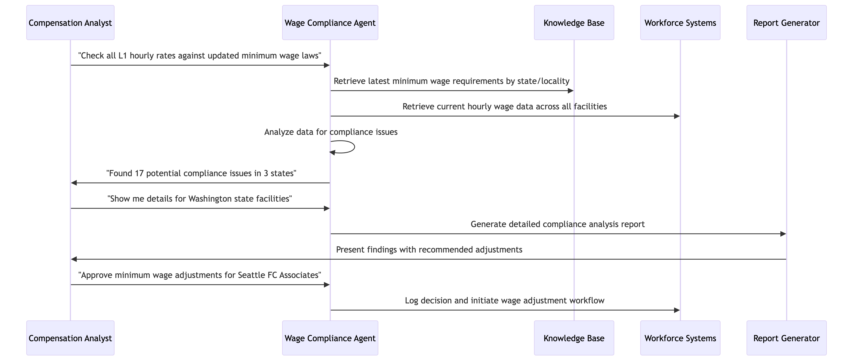**Workflow 1: Minimum Wage Compliance Review Process**

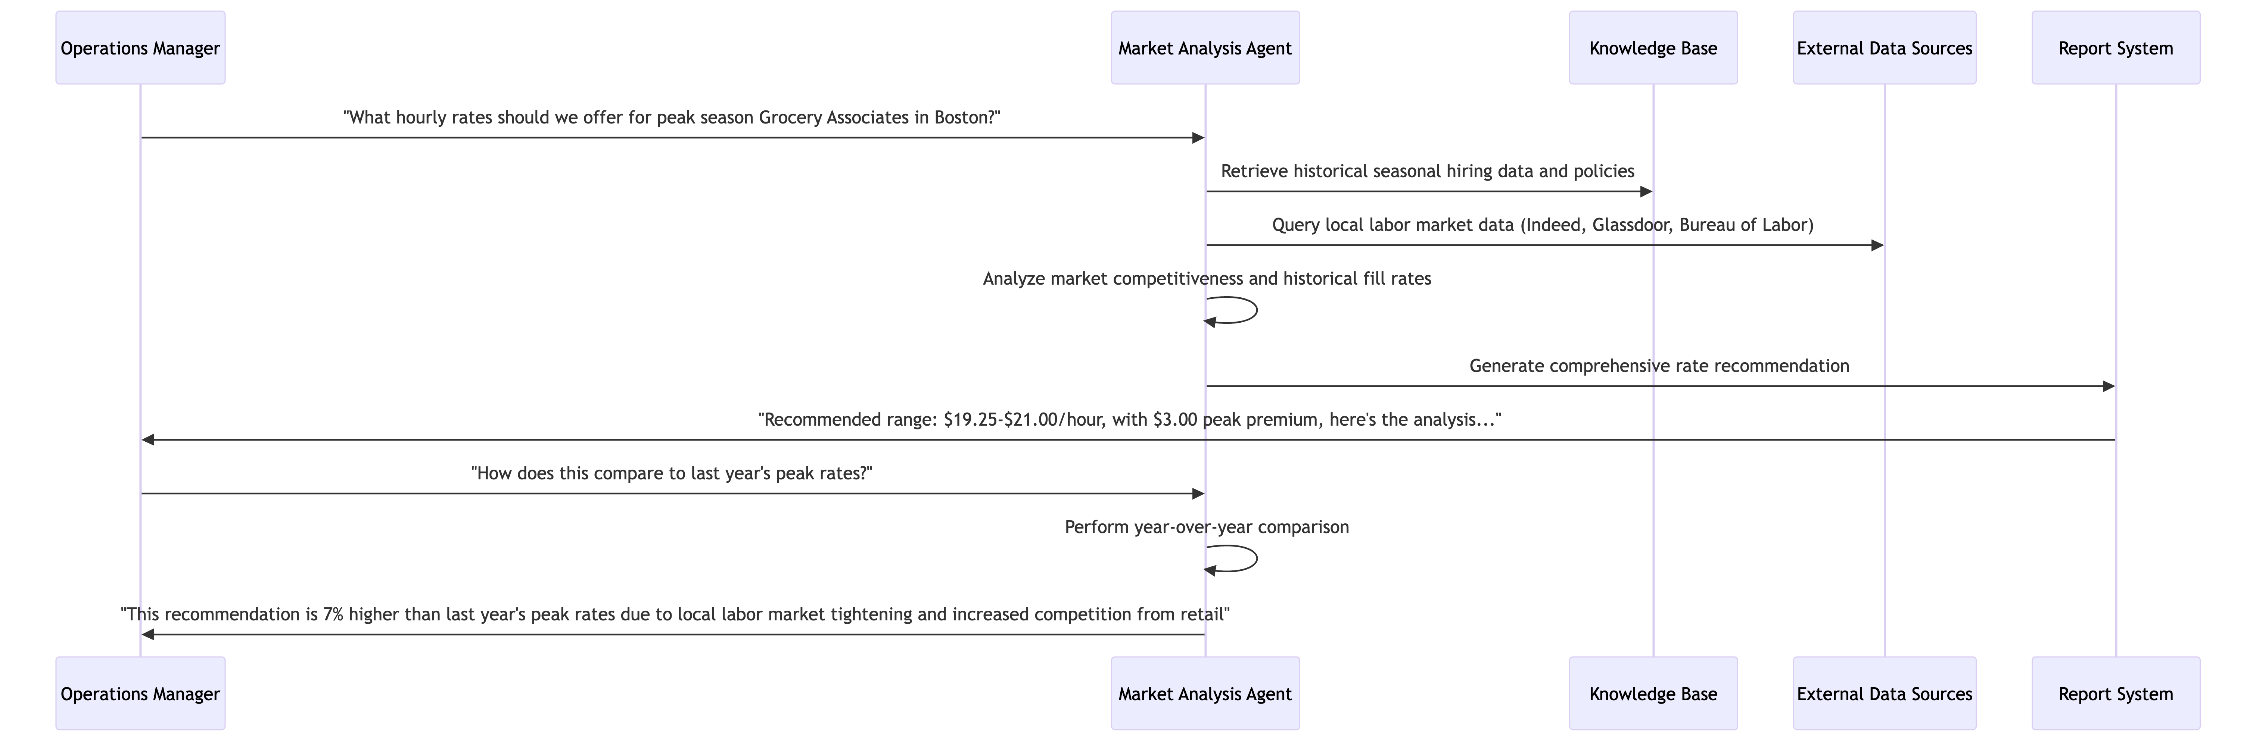**Workflow 2: Seasonal Hiring Rate Analysis**

### Appendix D: Governance in Action - Real Scenarios

**Scenario 1: Preventing Geographic Wage Bias**

*Without Governance:* AI agent recommends lower starting wages for facilities in areas with similar cost of living but different demographic compositions, inadvertently perpetuating geographic wage disparities.

*With Governance:*

* Bias detection algorithms flag the statistical disparity in wage recommendations
* Human review is triggered automatically
* Hourly compensation team investigates and adjusts recommendation
* AI model is retrained with additional fairness constraints
* All decisions are logged for compliance reporting and trend analysis

**Scenario 2: Handling Outdated Minimum Wage Data**

*Without Governance:* AI continues using outdated minimum wage requirements from 2023 after multiple states implemented increases in 2025, leading to compliance risks.

*With Governance:*

* Data freshness monitoring detects outdated wage regulations
* System automatically flags recommendations as "low confidence"
* Knowledge base refresh is triggered from authoritative sources
* Updated wage requirements are validated by legal team before use
* Users are notified of the data refresh and improved confidence scores

**Scenario 3: Managing "Orphaned" Shift Optimization AI**

*Without Governance:* BIE builds shift differential optimization agent, then leaves team. Agent continues running with outdated assumptions about labor availability.

*With Governance:*

* Dual ownership model ensures continuity (business + technical owners)
* Automated monitoring detects increasing variance between recommendations and actual labor market response
* Ownership transition protocols activate when team member leaves
* New technical owner updates the model with current labor market dynamics
* Business owner validates continued relevance and accuracy of recommendations

### Appendix E: Technology Glossary

|  |  |  |
| --- | --- | --- |
| **Term** | **Definition** | **Hourly Compensation Context** |
| Model Context Protocol (MCP) | Standardized way for AI agents to access and use relevant information when making decisions | Ensures AI agents have access to current minimum wage laws, shift premium policies, and local market data when making recommendations |
| Agentic Computing | AI systems that can autonomously perform complex tasks by coordinating multiple specialized agents | Multiple AI agents work together - one checks compliance with wage laws, another analyzes local market data, a third generates recommendations |
| 95% Confidence Threshold | Minimum acceptable accuracy rate for AI recommendations before they can be presented to users | AI recommendation for hourly rate adjustment must be 95% confident based on available data and validation checks |
| Dual Ownership Model | Each AI system has both a business owner (understands the domain) and technical owner (maintains the system) | Hourly compensation analyst owns business logic for wage compliance agent; BIE owns technical maintenance and updates |
| Amazon Kendra | AI-powered search service that can extract insights from unstructured documents | Automatically indexes wage policies, state regulations, and labor market surveys for AI agent access |
| Pippin Integration | Connects AI capabilities with existing product management workflows | Operations managers can ask hourly workforce questions directly in their existing tools |

### Appendix F: Implementation Phases Detail

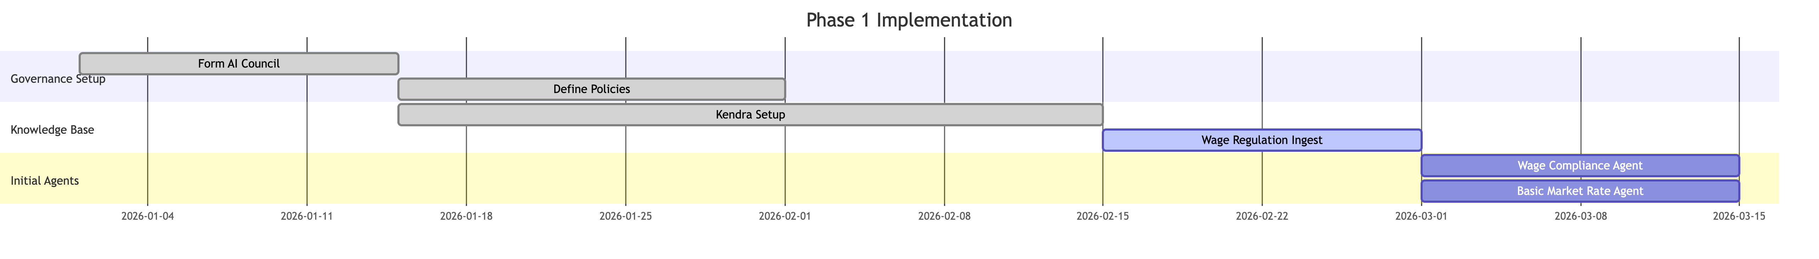**Phase 1: Foundation (Months 1-3)**

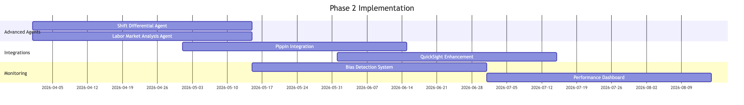**Phase 2: Core Capabilities (Months 4-9)**

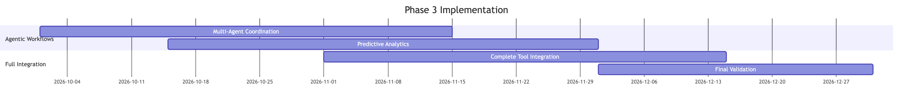**Phase 3: Advanced Intelligence (Months 10-12)**

### Appendix G: Business Impact Projections

**Efficiency Gains:**

* 65% reduction in time spent on wage compliance verification
* 80% faster response time for local market rate questions
* 45% improvement in seasonal staffing plan optimization time

**Quality Improvements:**

* 95% confidence threshold ensures higher accuracy than manual analysis
* Elimination of human error in minimum wage compliance calculations
* Consistent application of wage policies across all facilities and jurisdictions

**Risk Reduction:**

* Proactive compliance monitoring prevents wage law violations
* Automated market analysis ensures competitive hourly wages to reduce attrition
* Complete audit trails support legal defense and compliance reporting

**Strategic Value:**

* Real-time local market intelligence enables more competitive wage strategies
* Predictive analytics help anticipate turnover risks and labor market changes
* Data-driven insights support more effective labor budget planning and workforce allocation

### Appendix H: Change Management Strategy

**Addressing Common Concerns:**

|  |  |  |
| --- | --- | --- |
| **Stakeholder Concern** | **Response Strategy** | **Supporting Evidence** |
| "AI will replace hourly workforce planners" | Position AI as augmentation, not replacement. Show how AI handles routine tasks so analysts can focus on strategic work | Include examples of enhanced workforce planning capabilities that require human judgment |
| "AI recommendations might disadvantage certain areas" | Demonstrate comprehensive bias detection and human oversight mechanisms | Reference geographic equity framework and compliance audit processes |
| "The technology is too complex for our operations" | Provide simple, intuitive interfaces and comprehensive training | Show Pippin integration examples that use natural language |
| "What if the AI misinterprets wage requirements?" | Explain confidence thresholds, human review processes, and audit trails | Detail the 95% confidence requirement and legal validation procedures |
| "This will be expensive to implement for hourly roles" | Present clear ROI analysis and phased implementation approach | Include labor cost optimization projections and compliance risk reduction |